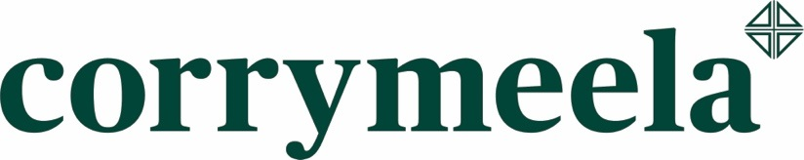
Booking Form

Event: | Hope A Light in the Darkness - Reflections on Chanukah and Christmas  Saturday 26 November 2016, 10am – 3.30pm  Corrymeela Ballycastle, 5 Drumaroan Road, Ballycastle, BT54 6QU
Name: | Mr / Mrs / Miss / Ms
Address:

Postcode:
Telephone/Mobile:
Email Address:

Logistical Details:
Vegetarian [ ] Vegan [ ] Allergies/Other [ ]

Please mark box with ‘X’
Please give details:
Any Other Information:
(e.g. medical/access/other needs)

PAYMENT TO SECURE YOUR BOOKING - this one-day retreat costs £20.00 per person (including lunch and refreshments) – please book early to avoid disappointment.
Please either

Email this completed form to belfast@corrymeela.org with Hope in the Subject line – then call our Belfast Office to make payment by credit/debit card – 028 9050 8080 (Mon-Fri 9am - 4.30pm).

0r

Post your completed form with a cheque for £20.00 made payable to the Corrymeela Community to:

Hope
Corrymeela
83 University Street
Belfast
BT7 1HP

If you have any booking enquiries, please contact belfast@corrymeela.org or call 028 9050 8080

